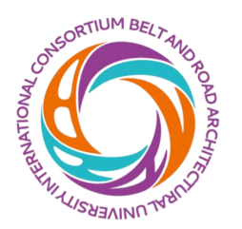

2024 Summer School on Smart Cities

July 14-22, 2024

APPLICATION FORM

Please complete this application form and send it to: buceaiss@hotmail.com no later than
10 June 2024. Applications received after this date WILL NOT be considered. The organizers will review the applications and send the notification of acceptance to those who meet the requirements.

Given Name |  |  | Last Name
Gender | Female Male |  | Date of Birth
Nationality |  |  | Passport No.
Degree Towards Your Study |  | Bachelor Master PhD
Major
English Level (CET/TOEFL/IELTS)
Organization (indicate the department of your university or agency)
Position
Contact address
Telephone Number
Mobile Number
Fax
Email Address

